CONTENT
1.Introduction
1.1 Project Overview
1.2 Objectives
1.3 Scope
- Project Structure
  - Folder and File Organization
  - Description of Key Files
3.Project Requirements
  - Python Version
  - Python Libraries
  - Database Requirements
  - Frontend / Browser Requirements
4.Database Design
  - Tables and Fields
  - Relationships
5.Application Functionality
  - Dashboard Overview
  - Active Vehicles Management
  - Vehicle History Management
  - Admin Login and Management
6.Static Assets
  - CSS Styling (Glass-morphism, Glow
Slots)
  - JavaScript Features
  - Images and Icons
7.Deployment Instructions
  - Installing Dependencies
  - Running the Flask App
  - Database Setup
8.Conclusion
  - Achievements
  - Future Enhancements

1.Introduction

1.1 Project Overview
The Vehicle Parking Management System is a web-based application developed to efficiently manage vehicle parking operations in parking areas such as malls, offices, apartments, and public parking spaces. The system helps administrators monitor vehicle entry and exit, track parking availability, and maintain records of parked vehicles.
The application is built using the Python programming language with the Flask web framework. It uses a database to store vehicle information, parking history, and administrative data. The system provides a user-friendly dashboard for managing parking activities in real time.
This system reduces manual work, improves parking efficiency, and helps maintain accurate records of vehicles entering and leaving the parking premises.

1.2 Objectives
The main objectives of the Vehicle Parking Management System are:
- To automate the parking management process.
- To record vehicle entry and exit details.
- To maintain a history of parked vehicles.
- To provide a simple dashboard for monitoring active vehicles.
- To improve parking space management and efficiency.
- To reduce manual errors in maintaining parking records.

1.3 Scope
The scope of this project includes:
- Managing vehicle entry and exit records.
- Viewing currently parked vehicles.
- Maintaining vehicle parking history.
- Admin authentication for secure system access.
- Simple and responsive user interface for easy interaction.
The system is suitable for small to medium parking areas such as offices, apartments, and shopping complexes.

2. Project Structure

2.1 Folder and File Organization
The project follows a structured folder organization to maintain code readability and modularity.
Typical project structure: vehicle_parking_system/
├── backend/
│ │
│ ├── __pycache__/
│ │
│ ├── app.py
│ ├── config.py
│ ├── models.py
│ ├── routes.py
│ ├── test_api.py
│ │
│ ├── requirements.txt
│ └── package-lock.json
│
│
├── frontend/
│ │
│ ├── node_modules/
│ │
│ ├── public/
│ │
│ ├── src/
│ │
│ ├── .gitignore
│ ├── package.json
│ ├── package-lock.json
│ └── README.md
│
├── templates/
│ │
│ ├── index.html
│ ├── dashboard.html
│ ├── parking_slots.html
│ └── vehicle_history.html
│
├── venv/
│ │
│ ├── Include/
│ ├── Lib/
│ │
│ ├── Scripts/
│ │ ├── activate
│ │ ├── activate.bat
│ │ ├── Activate.ps1
│ │ ├── deactivate.bat
│ │ ├── pip.exe
│ │ ├── pip3.exe
│ │ ├── pip3.12.exe
│ │ ├── python.exe
│ │ └── pythonw.exe
│ │
│ └── pyvenv.cfg
└── README.md

2.2 Description of Key Files

app.py
Main Flask application file containing routes, database operations, and application logic.

database.db
SQLite database used to store vehicle and admin information.
templates folder
Contains HTML files used for the web interface.

static folder
Contains CSS, JavaScript, images, and other static assets.

requirements.txt
Lists all Python libraries required to run the project.

3. Project Requirements

3.1 Python Version
The project requires:
Python 3.12 or higher

3.2 Python Libraries
Required libraries include:
- Flask
- SQLite3
- Flask-Login (optional for authentication)
- Jinja2 (template engine)
These libraries help build the backend logic, handle routing, and connect with the database.

3.3 Database Requirements
The system uses SQLite database, which is lightweight and easy to integrate with Python applications. It stores vehicle records, parking history, and admin login credentials.

3.4 Frontend / Browser Requirements The frontend is developed using:
- HTML5
- CSS3
- JavaScript
Supported browsers include:
- Google Chrome
- Mozilla Firefox
- Microsoft Edge
- Safari

- Database Design

4.1 Tables and Fields

Admin Table
Field Type | Description
id Integer | Primary key
username Text | Admin username
password Text | Admin
password

Active Vehicles Table
Field Type | Description
id Integer | Primary key
vehicle_number Text | Vehicle number
vehicle_type Text | Car/Bike
entry_time DateTime | Entry time

Vehicle History Table
Field Type | Description
id Integer | Primary key
vehicle_number Text | Vehicle number
vehicle_type Text | Type of vehicle

4.2 Relationships
- When a vehicle enters, it is added to the Active Vehicles table.
- When a vehicle exits, the record is removed from Active Vehicles and stored in the Vehicle History table.
- The Admin table manages login authentication.

5. Application Functionality

5.1 Dashboard Overview
The dashboard provides an overview of the parking system, including:
- Total active vehicles
- Total parking history
- Quick access to vehicle management sections
The dashboard acts as the central control panel for the administrator.

5.2 Active Vehicles Management
This module manages vehicles currently parked in the parking area. Functions include:
- Adding a new vehicle entry
- Viewing active vehicles
- Removing vehicles when they exit
- Recording entry time automatically

5.3 Vehicle History Management
This module maintains a record of all vehicles that have used the parking facility.
Features include:
- Viewing past parking records
- Tracking entry and exit time
- Searching vehicle records
This helps in monitoring parking usage and maintaining logs.

5.4 Admin Login and Management
The system provides a secure login system for administrators. Features include:
- Admin authentication
- Secure access to dashboard
- Restricting unauthorized access
Only authorized users can manage vehicle records.

6. Static Assets

6.1 CSS Styling (Glass-morphism, Glow Slots)
The user interface uses modern CSS design techniques such as:
- Glass-morphism effects for transparent UI panels
- Glow slot effects for highlighting parking slots
- Responsive layouts for different screen sizes
These styles improve the visual appearance and usability of the system.

6.2 JavaScript Features
JavaScript is used to add interactive functionality such as:
- Dynamic updates on dashboard
- Form validation
- Real-time user interface interactions
- Confirmation dialogs for vehicle removal

6.3 Images and Icons
Icons and images are used to enhance the user interface.
Examples include:
- Vehicle icons
- Parking slot icons
- Dashboard navigation icons
They improve usability and make the interface more intuitive.

7. Deployment Instructions

7.1 Installing Dependencies
Install required Python libraries using:
pip install -r requirements.txt

7.2 Running the Flask App Run the application using:
python app.py
Then open the browser and go to:
http://127.0.0.1:5000

7.3 Database Setup
The SQLite database is created automatically when the application runs for the first time.
Alternatively, the database can be initialized using SQL scripts provided in the project.

8. Conclusion

8.1 Achievements
The Vehicle Parking Management System successfully automates the parking management process. It provides a simple interface for administrators to manage vehicle entry, exit, and history records. The system improves efficiency, reduces manual work, and maintains accurate parking data.

8.2 Future Enhancements
Future improvements may include:
- Integration with automatic number plate recognition
- Online parking slot booking
- Mobile application support
- Payment gateway integration
- Real-time parking slot display
These enhancements will make the system more advanced and suitable for large-scale parking facilities.

Appendix A: Project Code

- The following section contains the core source code of the Vehicle Parking Management System project. Each file is presented separately with its corresponding file name as a header, along with the essential functions and components that implement the parking management operations.
- The code is organized according to the project folder structure and demonstrates the major functionalities of the system, including vehicle entry, exit management, parking slot allocation, and user interface handling.
- The main components included in this appendix are:
- • Application backend logic for parking operations (app.py) – Handles vehicle parking, vehicle exit, and slot management using the Flask web framework.
- • Configuration and system settings (config.py) – Contains application configuration settings such as database paths and environment variables.
- • Database model definitions (models.py) – Defines the database schema including vehicle records and parking slot information.
- • Route management and request handling (routes.py) – Implements the application routes for parking vehicles, exiting vehicles, and viewing slot status.
- • Frontend template rendering (index.html) – Provides the user interface for interacting with the parking management system.
- • Styling and user interface design (style.css) – Contains the CSS used to design the system interface and display slot availability visually.
- • Application entry point and initialization – The Flask application is initialized and executed through the main application file, which starts the web server and loads the system components.
- Note: Indentation, variable names, and comments within the code have been preserved to maintain readability and clarity. Some lengthy scripts have been shortened to highlight only the core functionalities necessary for understanding the working of the parking management system. For the complete source code and additional implementation details, refer to the full project files provided with the system.

Appendix B: HTML Templates

- This appendix contains the HTML templates used in the Vehicle Parking Management System. These templates form the user interface of the application and allow users to interact with the parking management functionalities through a web browser.
- The templates are designed using HTML5 and are integrated with the Flask framework using the Jinja2 templating engine. Jinja2 allows dynamic content to be rendered in the HTML pages by passing data from the Flask backend to the frontend.
- The HTML templates are stored inside the templates folder of the project directory. These files define the layout, structure, and elements of the web pages used in the system.
- The major HTML templates used in the system are described below.

Index.html
<!DOCTYPE html>
<html lang="en">
<head>
<meta charset="UTF-8">
<title>Vehicle Parking Management</title>
</head>
<body>
<div id="root"></div>
</body>
</html>

Appendix C: CSS and JavaScript

App.css:
.App { text-align: center;
}
.App-logo { height: 40vmin; pointer-events: none;
}

@media (prefers-reduced-motion: no-preference) {
.App-logo {
animation: App-logo-spin infinite 20s linear;
}
}

.App-header { background-color: #282c34; min-height: 100vh; display: flex; flex-direction: column; align-items: center; justify-content: center; font-size: calc(10px + 2vmin); color: white;
}
.App-link { color: #61dafb;
}

@keyframes App-logo-spin { from { transform: rotate(0deg);
} to {
transform: rotate(360deg);
}
}
App.js

import logo from './logo.svg'; import './App.css';

function App() { return (
<div className="App">
<header className="App-header">
<img src={logo} className="App-logo" alt="logo" />
<p>
Edit <code>src/App.js</code> and save to reload.
</p>
<a
className="App-link" href="https://reactjs.org" target="_blank" rel="noopener noreferrer"
>
Learn React
</a>
</header>
</div>
);
}

export default App;

App.test.js: import { render, screen } from '@testing-library/react'; import App from './App';

test('renders learn react link', () => { render(<App />); const linkElement = screen.getByText(/learn react/i); expect(linkElement).toBeInTheDocument();
});

Index.css
body { margin: 0;
font-family: -apple-system, BlinkMacSystemFont, 'Segoe UI', 'Roboto', 'Oxygen',
'Ubuntu', 'Cantarell', 'Fira Sans', 'Droid Sans', 'Helvetica Neue',
sans-serif;
-webkit-font-smoothing: antialiased;
-moz-osx-font-smoothing: grayscale;
}

code {
font-family: source-code-pro, Menlo, Monaco, Consolas,
'Courier New', monospace;
}

Index.js:
import React from 'react';
import ReactDOM from 'react-dom/client'; import './index.css'; import App from './App';
import reportWebVitals from './reportWebVitals';

const root =
ReactDOM.createRoot(document.getElementById('root')); root.render(
<React.StrictMode>
<App />
</React.StrictMode>
);

// If you want to start measuring performance in your app, pass a function
// to log results (for example: reportWebVitals(console.log))
// or send to an analytics endpoint. Learn more: https://bit.ly/CRAvitals reportWebVitals();

reportWebVitals.js
const reportWebVitals = onPerfEntry => { if (onPerfEntry && onPerfEntry instanceof Function) { import('web-vitals').then(({ getCLS, getFID, getFCP, getLCP, getTTFB }) => { getCLS(onPerfEntry); getFID(onPerfEntry); getFCP(onPerfEntry); getLCP(onPerfEntry); getTTFB(onPerfEntry);
});
}
};

export default reportWebVitals;

Appendix D: BACKEND(Python,MySQL)

App.py
from routes import app # Import your Flask app from routes.py

if __name__ == "__main__":
app.run(debug=True)

config.py
MYSQL_HOST = "localhost"
MYSQL_USER = "root"
MYSQL_PASSWORD = "Bhagya@123" MYSQL_DB = "parking_system"

Models.py from flask_mysqldb import MySQL

mysql = MySQL()

def init_app(app): mysql.init_app(app)

package-lock.json
{
"name": "backend",
"lockfileVersion": 3,
"requires": true,
"packages": {}
}
Routes.py:
from flask import Flask, request, jsonify, render_template, redirect, url_for, session from flask_mysqldb import MySQL from flask_cors import CORS from datetime import datetime from config import *

app = Flask(__name__)
CORS(app)

# Secret key for session app.secret_key = "supersecretkey"

# -----------------------------
# MySQL Config
# -----------------------------
app.config['MYSQL_HOST'] = MYSQL_HOST app.config['MYSQL_USER'] = MYSQL_USER app.config['MYSQL_PASSWORD'] = MYSQL_PASSWORD app.config['MYSQL_DB'] = MYSQL_DB
mysql = MySQL(app)

# -----------------------------
# Home route
# -----------------------------
@app.route('/') def home():
return render_template("index.html")

# -----------------------------
# Get all slots
# -----------------------------
@app.route('/slots', methods=['GET']) def get_slots():
cur = mysql.connection.cursor()
cur.execute("SELECT id, slot_number, is_occupied FROM slots")
data = cur.fetchall() cur.close()
slots = [
{"id": d[0], "slot_number": d[1], "is_occupied": bool(d[2])}
for d in data
]

return jsonify(slots)

# -----------------------------
# Park a vehicle
# -----------------------------
@app.route('/park', methods=['POST']) def park_vehicle(): data = request.json vehicle_number = data.get('vehicle_number') vehicle_type = data.get('vehicle_type')

if not vehicle_number or not vehicle_type:
return jsonify({"error": "Vehicle number and type are required"}), 400
cur = mysql.connection.cursor()

# Check if vehicle already parked cur.execute(
"SELECT * FROM vehicles WHERE vehicle_number=%s AND exit_time IS NULL",
(vehicle_number,)
)
if cur.fetchone():
cur.close() return jsonify({"error": "Vehicle already parked"}), 400

# Get first free slot cur.execute("SELECT id FROM slots WHERE is_occupied=FALSE LIMIT 1") slot = cur.fetchone()

if not slot: cur.close() return jsonify({"error": "No free slots available"}),
400

slot_id = slot[0] entry_time = datetime.now()

# Insert vehicle cur.execute(
"INSERT INTO vehicles (vehicle_number, vehicle_type, entry_time, slot_id) VALUES (%s,%s,%s,%s)",
(vehicle_number, vehicle_type, entry_time, slot_id)
)

# Mark slot occupied cur.execute(
"UPDATE slots SET is_occupied=TRUE WHERE id=%s",
(slot_id,)
)
mysql.connection.commit() cur.close()

return jsonify({
"message": "Vehicle parked",
"slot_id": slot_id,
"entry_time": str(entry_time)
})

# -----------------------------
# Exit a vehicle
# -----------------------------
@app.route('/exit', methods=['POST']) def exit_vehicle(): data = request.json vehicle_number = data.get('vehicle_number')

if not vehicle_number:
return jsonify({"error": "Vehicle number is
required"}), 400

cur = mysql.connection.cursor()

# Get vehicle cur.execute(
"SELECT id, entry_time, slot_id FROM vehicles
WHERE vehicle_number=%s AND exit_time IS NULL",
(vehicle_number,)
)
vehicle = cur.fetchone()

if not vehicle: cur.close()
return jsonify({"error": "Vehicle not found"}), 404

vehicle_id, entry_time, slot_id = vehicle exit_time = datetime.now() duration_hours = (exit_time -
entry_time).total_seconds() / 3600 fee = round(duration_hours * 20, 2)

# Update vehicle cur.execute(
"UPDATE vehicles SET exit_time=%s, fee=%s WHERE id=%s",
(exit_time, fee, vehicle_id)
)

# Free slot cur.execute(
"UPDATE slots SET is_occupied=FALSE WHERE id=%s",
(slot_id,)
)

mysql.connection.commit() cur.close()

return jsonify({
"message": "Vehicle exited",
"slot_id": slot_id,
"exit_time": str(exit_time),
"duration_hours": round(duration_hours, 2),
"fee": fee
})

# =============================
# ADMIN LOGIN SYSTEM
# =============================

# -----------------------------
# Login
# -----------------------------
@app.route('/login', methods=['GET', 'POST']) def login(): if request.method == 'POST':
username = request.form.get('username') password = request.form.get('password') # Simple static admin login if username == "admin" and password == "admin123":
session['admin'] = True return redirect(url_for('history')) else:
return "Invalid credentials"

return render_template("login.html")

# -----------------------------
# Logout
# -----------------------------
@app.route('/logout') def logout():
session.pop('admin', None) return redirect(url_for('login'))

# -----------------------------
# Vehicle History (Protected)
# -----------------------------
@app.route('/history') def history(): if not session.get('admin'):
return redirect(url_for('login'))

cur = mysql.connection.cursor() cur.execute("""
SELECT vehicle_number, vehicle_type, entry_time, exit_time, fee
FROM vehicles
ORDER BY entry_time DESC
""") data = cur.fetchall() cur.close()

vehicles = [] for v in data:
vehicles.append({
"vehicle_number": v[0],
"vehicle_type": v[1],
"entry_time": v[2],
"exit_time": v[3],
"fee": v[4]
})

return render_template("history.html", vehicles=vehicles)

# -----------------------------
# Run App
# -----------------------------
if __name__ == "__main__": app.run(debug=True)

test_api.py

import requests

BASE_URL = "http://127.0.0.1:5000"

# --------- Get slots ---------
response = requests.get(f"{BASE_URL}/slots") print("Slots:", response.json())

# --------- Park a vehicle --------- vehicle_data = {
"vehicle_number": "KA01AB1234",
"vehicle_type": "Car"
}
response = requests.post(f"{BASE_URL}/park", json=vehicle_data) print("Park Response:", response.json())

# --------- Check slots after parking --------- response = requests.get(f"{BASE_URL}/slots") print("Slots after parking:", response.json())

# --------- Exit the vehicle --------- exit_data = {
"vehicle_number": "KA01AB1234"
}
response = requests.post(f"{BASE_URL}/exit", json=exit_data) print("Exit Response:", response.json())

# --------- Check slots after exit --------- response = requests.get(f"{BASE_URL}/slots") print("Slots after exit:", response.json())

package.json:

{
"name": "frontend",
"version": "0.1.0",
"private": true,
"dependencies": {
"@testing-library/dom": "^10.4.1",
"@testing-library/jest-dom": "^6.9.1",
"@testing-library/react": "^16.3.2",
"@testing-library/user-event": "^13.5.0",
"react": "^19.2.4",
"react-dom": "^19.2.4",
"react-scripts": "5.0.1",
"web-vitals": "^2.1.4"
},
"scripts": {
"start": "react-scripts start",
"build": "react-scripts build",
"test": "react-scripts test",
"eject": "react-scripts eject"
},
"eslintConfig": {
"extends": [
"react-app",
"react-app/jest"
]
},
"browserslist": {
"production": [
">0.2%",
"not dead",
"not op_mini all"
],
"development": [
"last 1 chrome version",
"last 1 firefox version",
"last 1 safari version"
]
}
}

Appendix D: (MYSQL)

CREATE DATABASE IF NOT EXISTS parking_system;
USE parking_system;
CREATE TABLE IF NOT EXISTS slots (
id INT AUTO_INCREMENT PRIMARY KEY, slot_number VARCHAR(10) UNIQUE NOT NULL, is_occupied BOOLEAN DEFAULT FALSE); CREATE TABLE IF NOT EXISTS vehicles ( id INT AUTO_INCREMENT PRIMARY KEY, vehicle_number VARCHAR(20) NOT NULL, vehicle_type VARCHAR(20) NOT NULL, entry_time DATETIME NOT NULL, exit_time DATETIME NULL, fee DECIMAL(10,2) DEFAULT 0, slot_id INT,

CONSTRAINT fk_slot
FOREIGN KEY (slot_id)
REFERENCES slots(id)
ON DELETE SET NULL
);
CREATE TABLE IF NOT EXISTS admin ( id INT AUTO_INCREMENT PRIMARY KEY, username VARCHAR(50) UNIQUE NOT NULL, password VARCHAR(100) NOT NULL
);
INSERT INTO slots (slot_number, is_occupied) VALUES
('S1', FALSE),
('S2', FALSE),
('S3', FALSE),
('S4', FALSE),
('S5', FALSE);
INSERT INTO admin (username, password)
VALUES ('admin', 'admin123');
SELECT * FROM slots;

Project Screenshots:

BACKEND:
The backend installation process for the Vehicle Parking Management System involves setting up the server-side environment required to manage application logic and database operations. The backend of the system is developed using the Python Flask framework, which helps in handling user requests, processing data, and communicating with the database. To begin the installation process, Python must be installed on the system (version 3.7 or higher), and it can be downloaded from the official Python website. During installation, the option “Add Python to PATH” should be enabled so that Python commands can be executed from the command prompt. After installing Python, the project backend folder should be created inside the main project directory, which contains important files such as routes.py and database connection files.
Next, the required libraries must be installed using the pip package manager. The command prompt should be opened and navigated to the backend folder, and then the necessary packages can be installed using commands such as pip install flask, pip install flask-cors, and pip install pymysql. These libraries are used for creating the web server, allowing communication between the frontend and backend, and connecting the application with the database. Once all the required libraries are installed successfully, the backend server can be started by running the command python routes.py in the backend directory.
After executing this command, the Flask development server will start and display a message such as “Running on http://127.0.0.1:5000/”, which indicates that the backend server is successfully running and ready to process requests from the frontend application. This setup enables the system to handle user operations, manage parking data, process vehicle entry and exit details, and communicate with the database effectively.
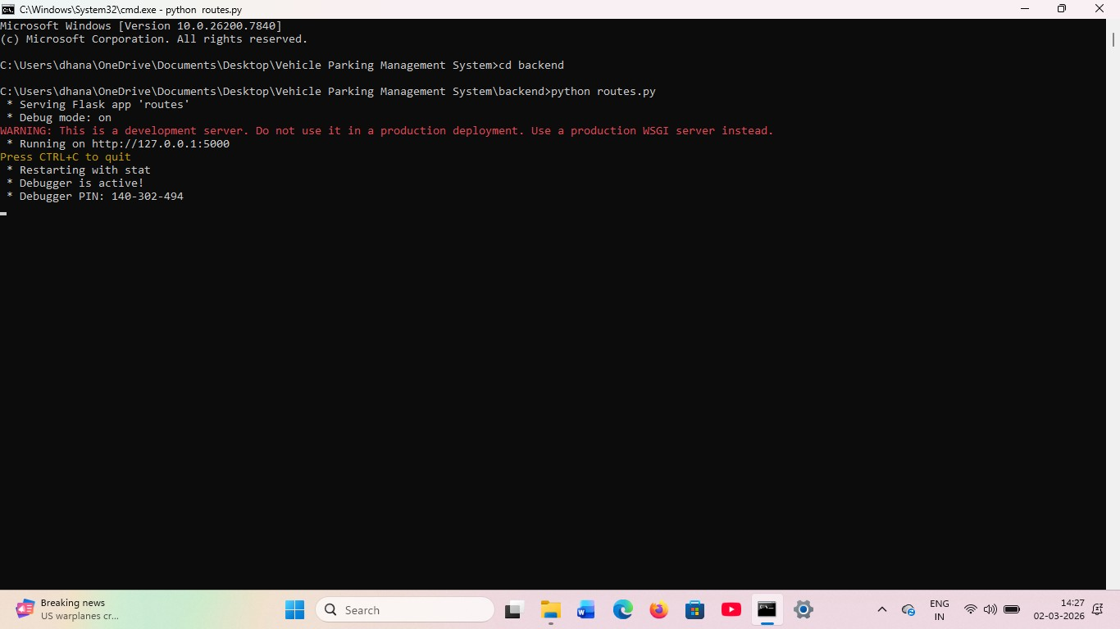

OUTPUT:

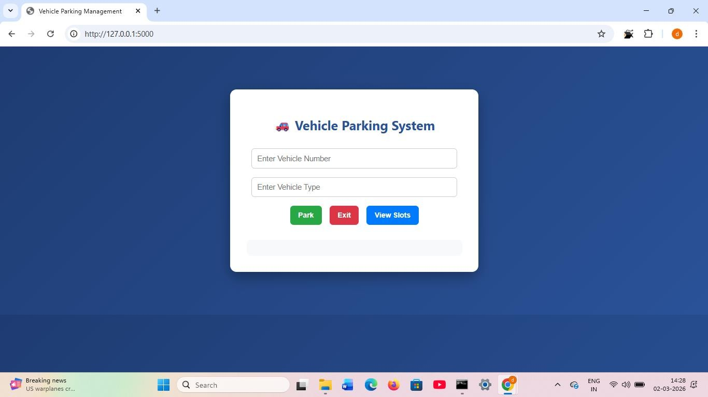

FRONTEND:
The frontend installation process for the Vehicle Parking Management System involves setting up the user interface that allows users to interact with the system. The frontend is developed using technologies such as HTML, CSS, JavaScript, and ReactJS to create a responsive and user-friendly interface. To begin the installation process, Node.js must be installed on the system because React applications require Node.js and npm (Node Package Manager) to manage dependencies and run the project.
Node.js can be downloaded and installed from the official website. After installation, the project folder should contain a separate frontend directory where all the client-side files such as components, styles, and configuration files are stored. Next, open the command prompt or terminal and navigate to the frontend folder using the appropriate command. Once inside the frontend directory, the required project dependencies must be installed using the command npm install, which automatically installs all the libraries and packages needed for the React application to run.
After the installation of dependencies is completed, the frontend development server can be started using the command npm start. This command will compile the React application and launch the project in the default web browser. The application will usually run on a local development server such as http://localhost:3000. Once the server starts successfully, the frontend interface becomes accessible, allowing users to view the parking management dashboard, enter vehicle details, check parking slot availability, and interact with the system. The frontend communicates with the backend server through API requests to fetch and send data, enabling smooth operation of the Vehicle Parking Management System.

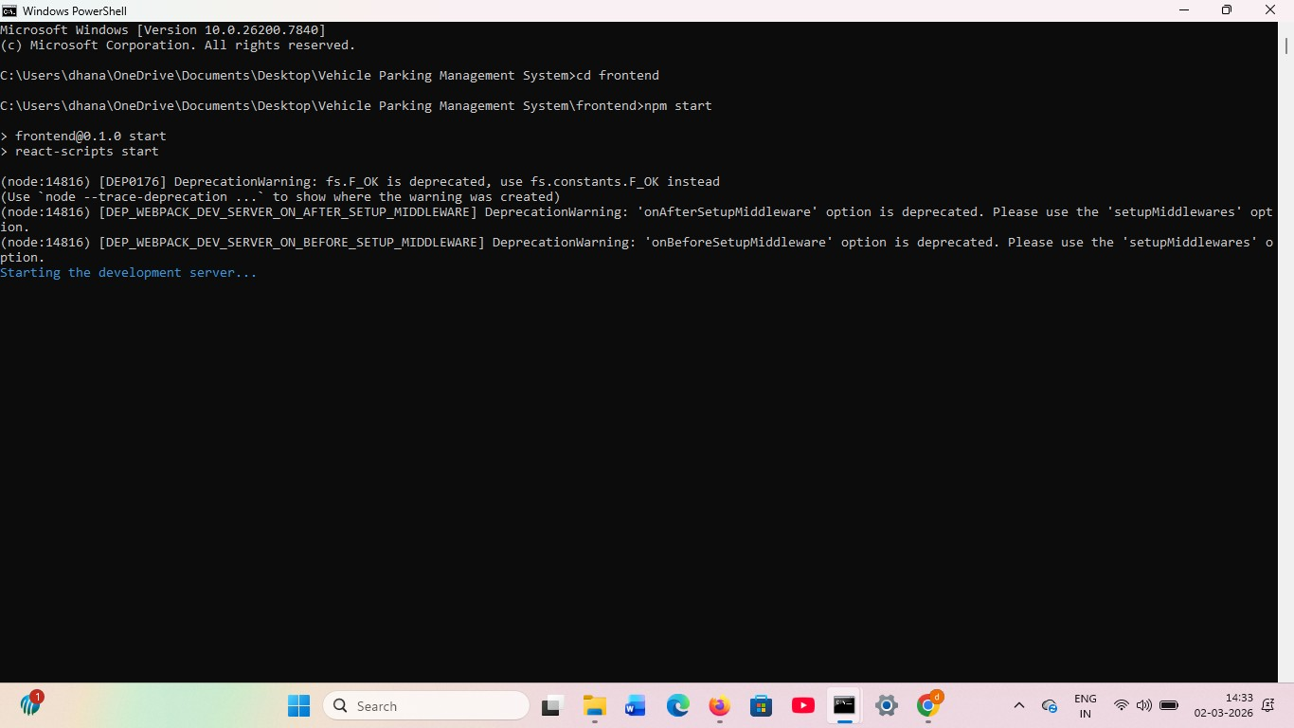

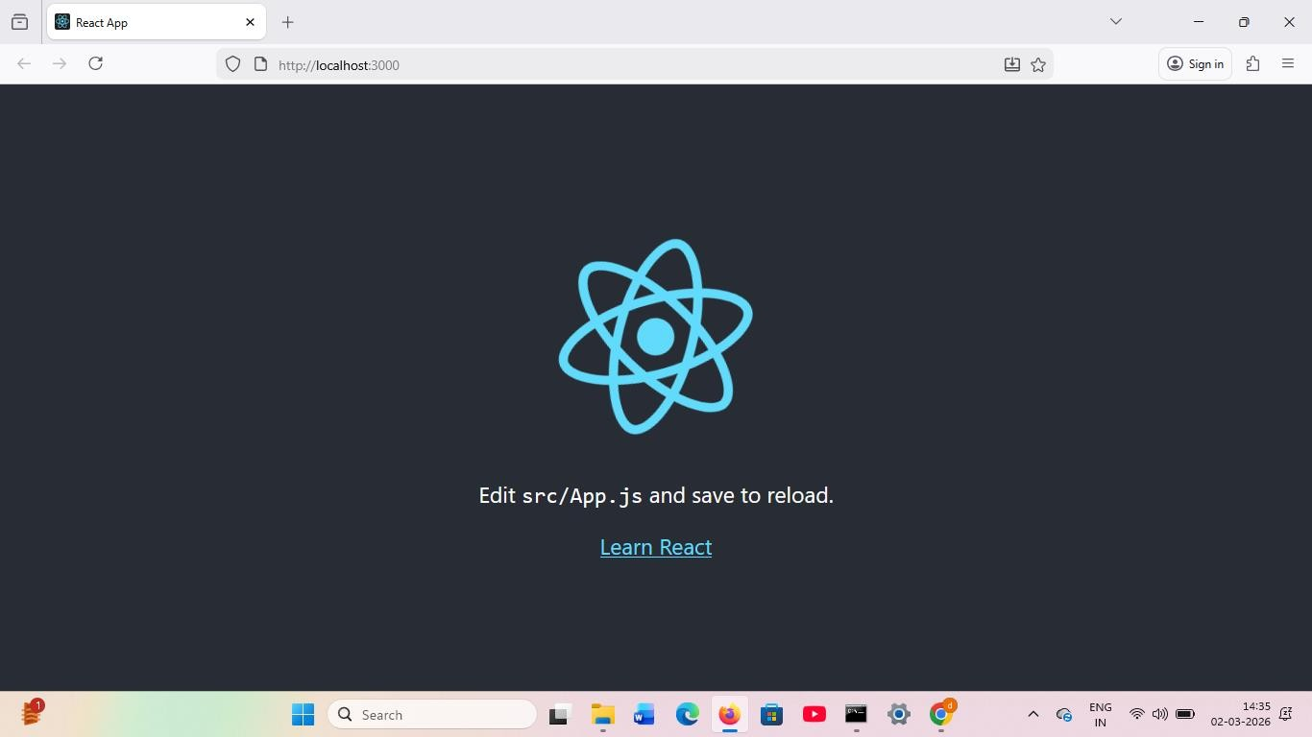
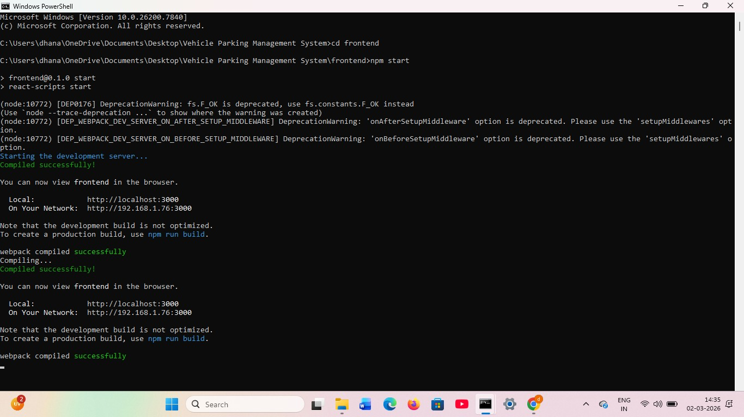

DATABASE(MYSQL):

The database for the Vehicle Parking Management System is implemented using MySQL, which is a popular relational database used for storing and managing structured data. In this system, MySQL is used to store important information such as vehicle details, parking slot availability, entry and exit records, and user data.
The database consists of tables where each table contains rows and columns to organize the data efficiently. To set up the database, MySQL must be installed on the system and a new database is created for the project. After creating the database, necessary tables are designed using SQL queries to store parking-related information.
The backend application developed using Flask connects to the MySQL database using a database connector, which allows the system to insert, update, retrieve, and delete data whenever required. This database helps the system manage parking records efficiently and ensures that all information is stored securely and can be accessed quickly when needed.

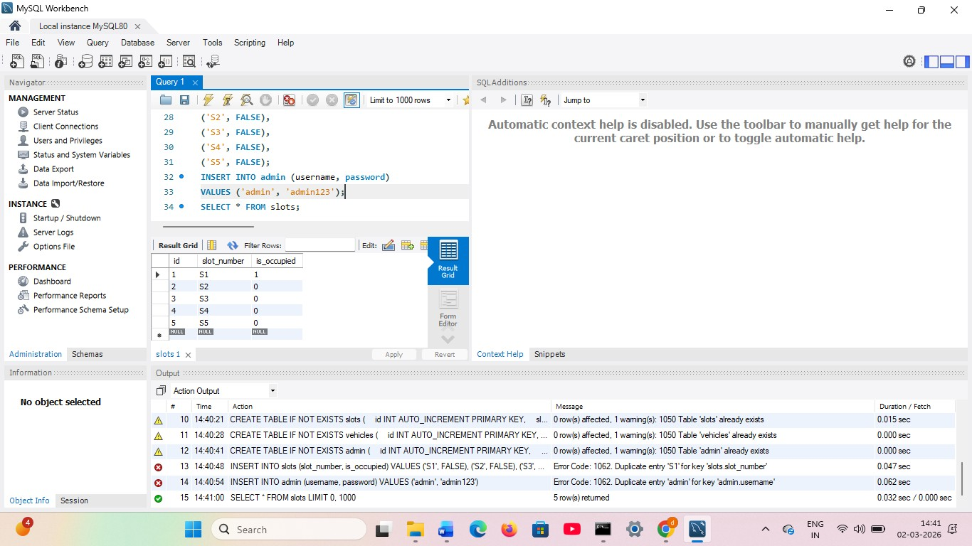
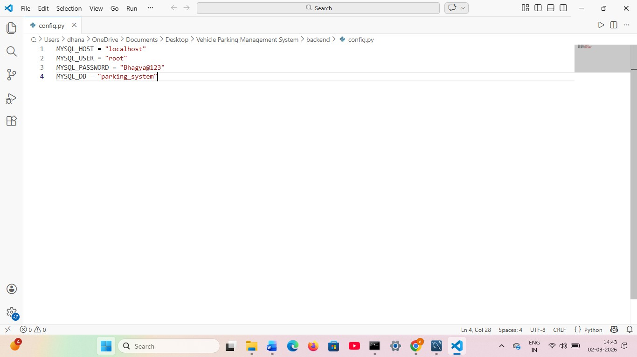

OUTPUT OF PROJECT:
The output of the Vehicle Parking Management System is the final result displayed to the user after processing vehicle and parking information through the system. The system provides a user-friendly interface where users can view parking slot availability, register vehicle details, and manage parking operations efficiently. When a vehicle enters the parking area, the system records the vehicle number, entry time, and assigned parking slot, and this information is stored in the database.
The system then displays details such as available parking spaces, occupied slots, and vehicle records on the screen. When the vehicle exits, the system updates the exit time and calculates the parking duration if required. The output also includes reports showing the list of parked vehicles, parking status, and parking history. This helps administrators monitor and manage the parking area effectively, reduce manual work, and improve overall parking management efficiency.
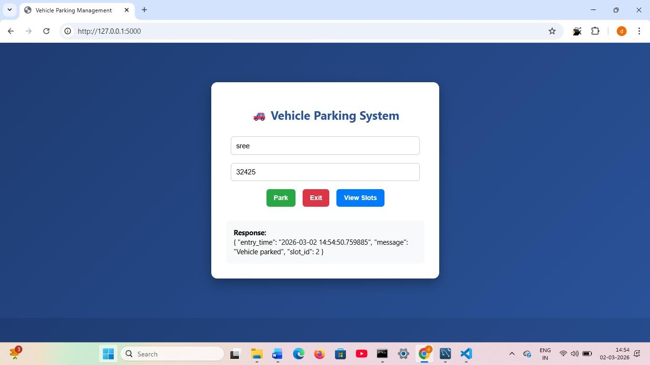

In the Vehicle Parking Management System, when a user enters a single input such as a vehicle number, the system processes the information and generates the corresponding output. For example, when the user enters the vehicle number in the input field and submits it, the system checks the database to verify the details and assigns an available parking slot. The system then stores the vehicle number along with the entry time and parking slot information in the database.
After processing the input, the system displays the output on the screen, such as confirmation of successful vehicle entry, the allotted parking slot number, and the recorded entry time. This output helps the parking administrator or user to easily track the parked vehicle and manage the parking space efficiently.

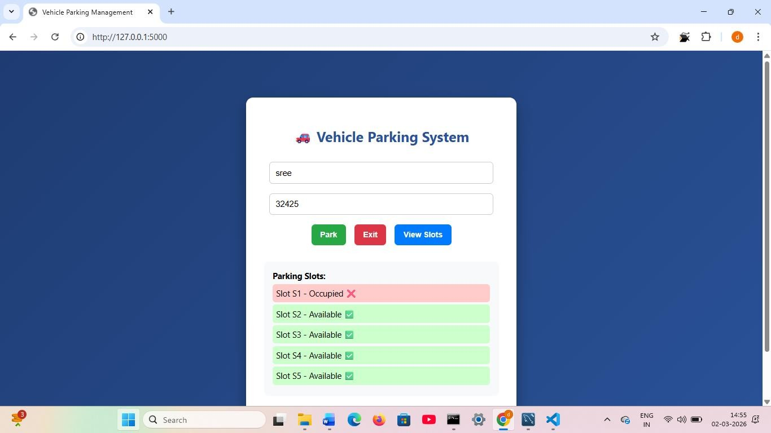

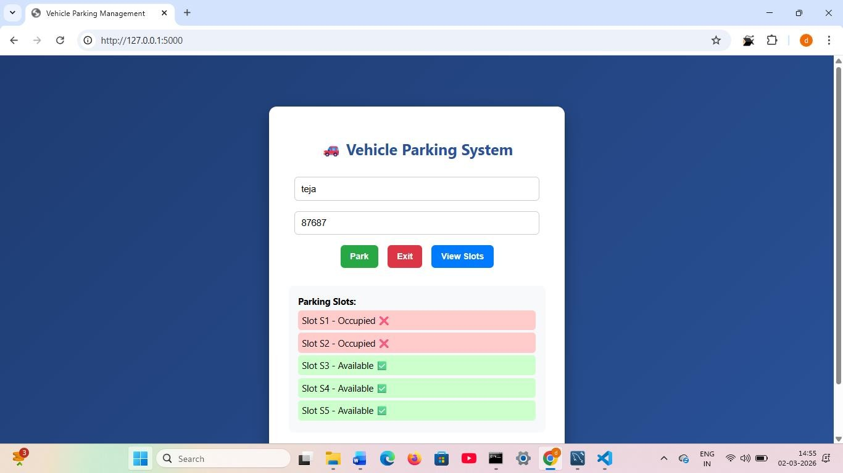

In the Vehicle Parking Management System, all the parking-related information is stored in a database for easy management and retrieval. When a user enters details such as the vehicle number, entry time, parking slot number, and other required information, the system processes the input and saves the data into the database.
The database stores this information in the form of tables consisting of rows and columns, which helps in organizing the data systematically. By storing data in the database, the system can easily retrieve, update, or delete records whenever necessary.
For example, when a vehicle exits the parking area, the system updates the exit time and parking details in the database. This storage process ensures that all vehicle records, parking slot availability, and parking history are maintained safely and can be accessed whenever required for monitoring and management purposes.

